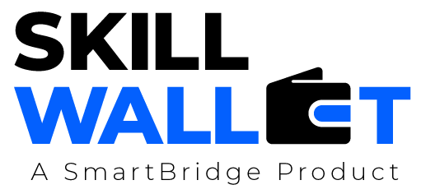

Communication

Date | 15th July 2926
Team ID | XXXXXX
Project Name | Rising Water
Maximum Marks | 1 Mark

Communication Plan:
Effective communication is essential for a successful project demonstration. This document outlines the communication strategy used within the team and with stakeholders throughout the project lifecycle, including how updates, issues, and feedback were managed.

S.No | Communication Type | Frequency | Channel / Tool | Participants | Purpose
1 | Team Standup | Daily | Google Meet / WhatsApp | All Team Members | Discuss daily tasks and project progress.
2 | Progress Update | Weekly | Google Meet / Microsoft Teams | Team Members & Mentor | Review completed work and plan upcoming tasks.
3 | Issue / Bug Discussion | As Needed | WhatsApp / VS Code / Google Meet | Developers & Team Members | Resolve coding errors, bugs, and technical issues.
4 | Stakeholder Review | Bi-Weekly | Google Meet | Team Members & Mentor | Receive feedback and improve the project.
5 | Final Demo Rehearsal | Once | Google Meet / Classroom | All Team Members | Practice the final project presentation and demonstration.
6 | Documentation Review | Weekly | Google Docs / WhatsApp | All Team Members | Verify project documentation and make necessary corrections.

Communication Challenges & Resolutions:
S.No | Challenge Faced | Resolution / Action Taken
1 | Difficulty integrating the machine learning model with the Flask application. | Collaborated as a team, debugged the code, and tested the application until it worked correctly.
2 | Dataset preprocessing issues such as missing values and inconsistent data. | Cleaned the dataset, handled missing values, and applied feature scaling before model training.
3 | Scheduling meetings due to different team member availability. | Used WhatsApp and Google Meet to coordinate discussions and assign tasks efficiently.

